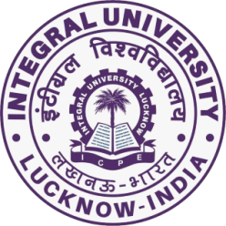

**Department of Biosciences**

**Integral University, Lucknow**

**Department of Biosciences,** Integral University, Lucknow**,** under the aegis of **United Nations Academic Impact (UNAI) Initiative**has organized various events on the **Theme: Basic Sciences for Sustainable Development**to commemorate **World Science Day for Peace and Development on 9th November 2022** in Hall-3, Central Auditorium Building at 2.00 pm. The purpose of the event was to highlight the important role of science in society and its aim was to ensure that citizens are kept informed of developments in science.

The event commenced with a welcome note and introduction of the program by **Dr. Snober S. Mir**, Head, Department of Biosciences. She stated the aim and importance of this year’s theme by UNAI initiative and the significance of basic sciences for sustainable development. An online lecture was delivered by our guest speaker

**Dr. T. V. Venkateshwaran,** **Scientist- F, Division Head-Science and Technology Communication, Vigyan Prasar, New Delhi.**His lecture emphasized on the Challenges before Indian science and possible solutions for a sustainable future. He discussed the challenges related to the geriatric diseases, climate changes and energy needs. The lecture was followed by an informative question-answer session.

Thereafter, the felicitation of the winners and runners up of various events was done by the event coordinators. Total four events were conducted for the celebration of World Science Day for Peace and Development.

The name of the events and the winners and runners up of the event are as follows:

**1)**     **Scientific Poster Making Competition (Technical Event)**

**Winner**- Aliya Fatima (B.Tech Biotechnology 2nd year)

**Runner up-** Atiya Tarique and Kratika Dwivedi (M.Sc. Biotechnology 1st year)

**2)**    **Chem-BioArt Tattoo Making Competition (Artistic event)**

**Winner-** Zehra Asif (B.Sc. Biotechnology 1st year)

**Runner up-** Tehreen Junaid (B.Sc. Biotechnology 1st year)

**3)**    **SciArt   Rangoli Competition (Artistic event)**

**Winner-** Group-3- Aliya Siddiqui, Anam Fatima Abdi, Aliza Fatima Rizvi (M.Sc. Microbiology 2nd year)

**Runner up-** Group 7- Sakshi Rastogi, Jaya Singh, Aqsa Zainab (B.Tech Biotechnology)

**4)**     **Open Mic (Artistic event)**

**Winner-**Affan Rais for stand-up comedy (B.Sc. Biotechnology 3rd year)

**Runner up-**Rushna Ahmad for poetry (B.Sc. ZBC 3rd year)

The organizing secretaries of the program were **Dr. Uzma Afaq,**Assistant Professorand**Dr. Amita Dubey,**Assistant Professor from the department of Biosciences. **Dr. Uzma Afaq** extended a vote of thanks and the anchor of the program was **Ms. Mushfa Khatoon,** Research Scholar, Department of Biosciences. More than 200 students participated in various events of the program. All events were very well coordinated by the faculty members and Student Council Biosciences.

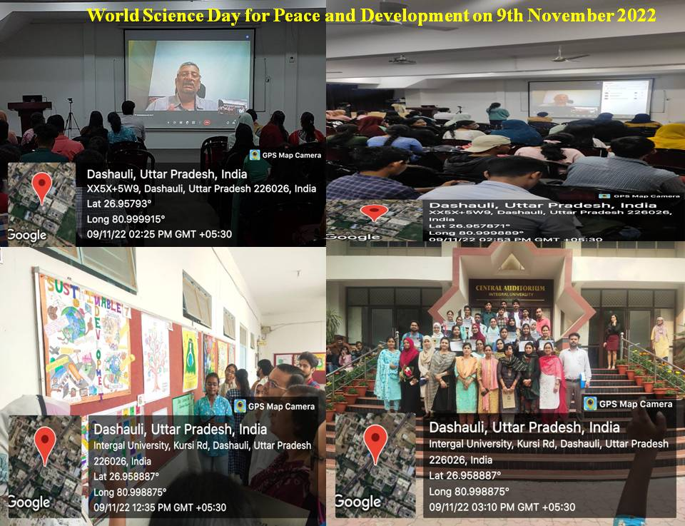

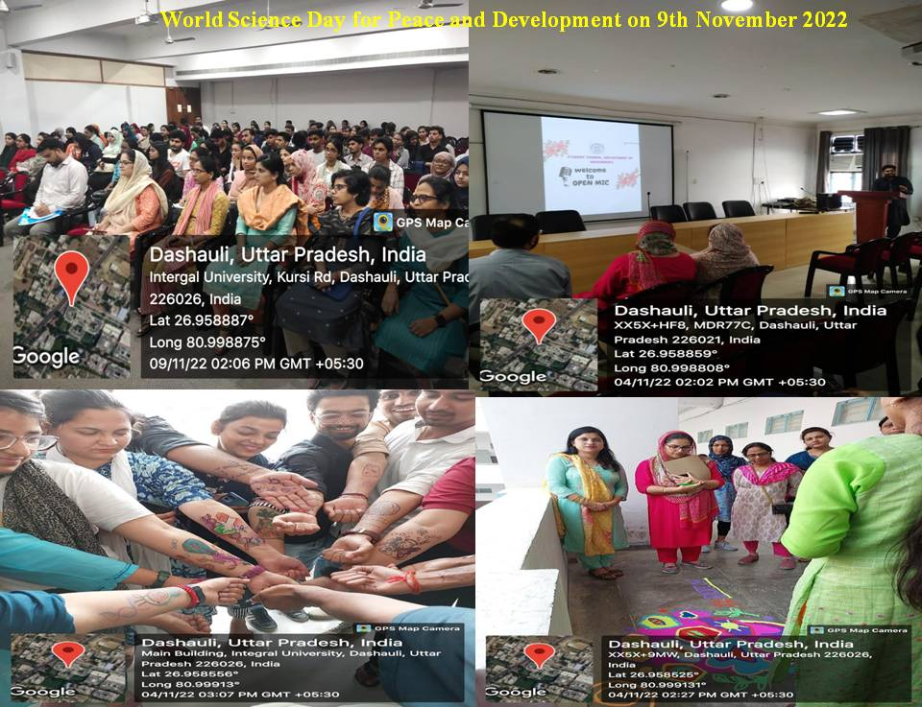

**(Snober S. Mir)**

**Head**

**Department of Biosciences**